Case 17-AM,C-Taino-Zemi-Anthropomorphic Head-Third Type-Shortened Base-Fewkes-1000-1500

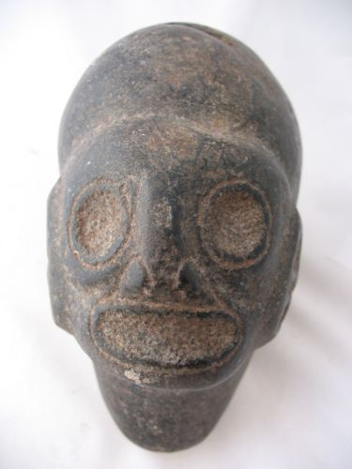

Case No.: 17
Accession Number:
Formal Label:
Display Description:
These stone heads may have originated from the practice of maintaining ossuaries of important caciques or shamans since ancestor worship was a central aspect of Taino spirituality. In ceremonial practice these objects were the conduits to the spirit world and, as such, were consulted on issues of importance to the decision-making of prominent leaders. Features of these sculptures included head bands that may have indicated symbolic elements denoting a particular cacique or group, ear elements that often included a round ear spool below the ear itself, the shape of the chin in various degrees of sharpness, and the shape of the mouth, whether it be open as if in pronouncing an utterance or closed showing only dentition, suggesting a deceased ancestor’s skull.

LC Classification:
Date or Time Horizon:
Geographical Area:
Map:
GPS Coordinates:
Cultural Affiliation:
Medium:
Dimensions: L 6 in, H 4.75 in, W 3.5 in
Weight: 5.5 lbs
Provenance:
Condition:
Discussion:
Jesse Walter Fewkes suggested three types of these anthropomorphic heads. The first is with an elongated base. The second type according to Fewkes is ovate with a flat base. The third type is a head without an extended base.

References:

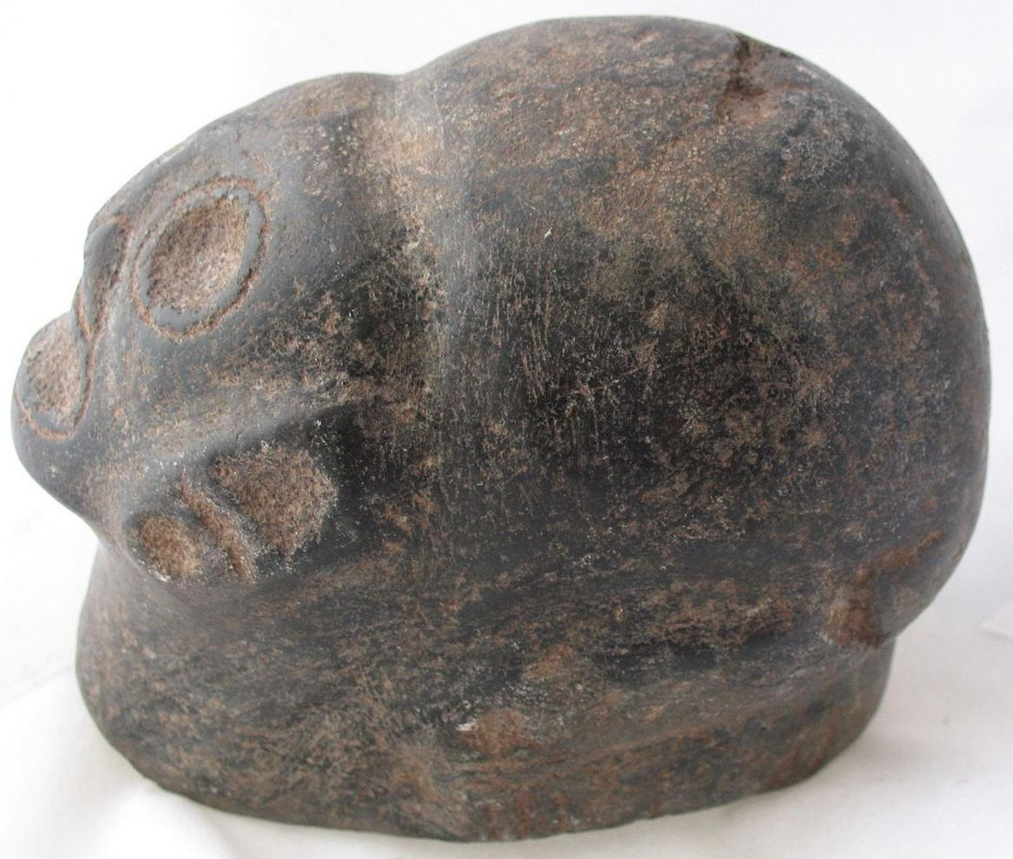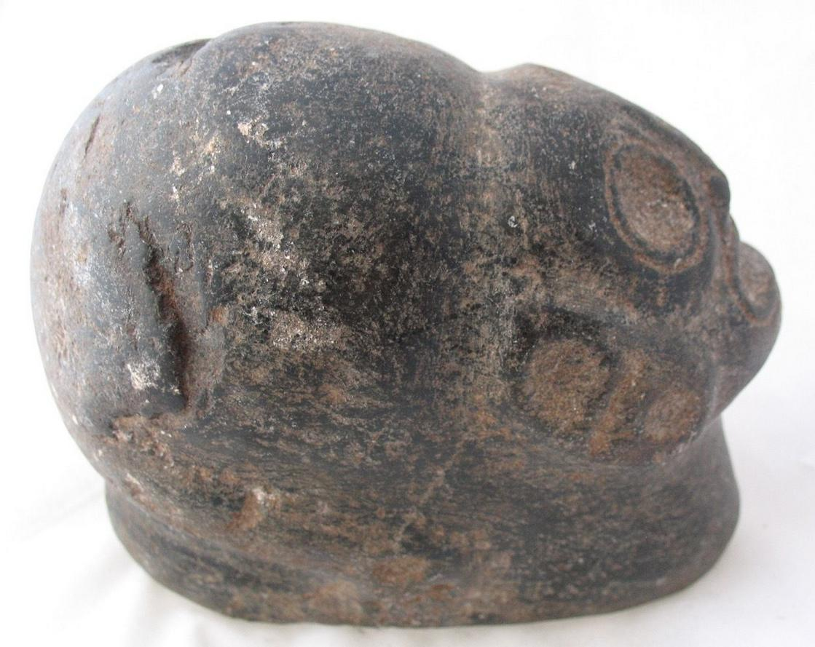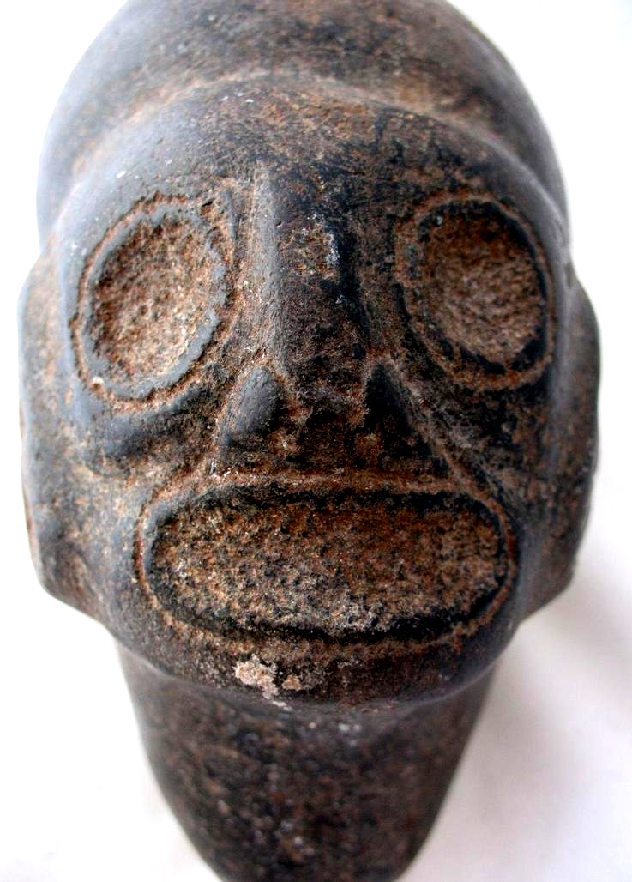
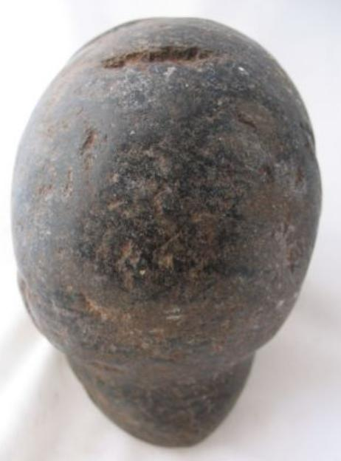

Winning bid:
US $271.00
[ 23 bids ]
Shipping:
$15.00 Expedited Shipping
Item location:
Fort Lauderdale, Florida, United States

